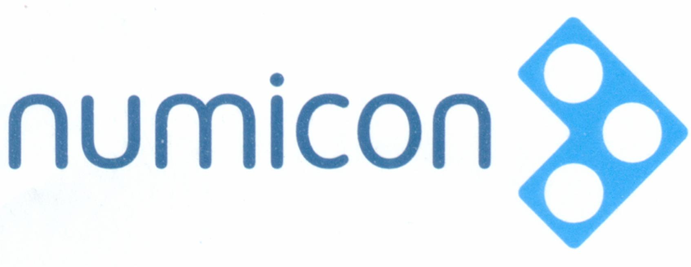

Numicon 1 Milestones Learning Record

Name:___________________________________ Date: _________________________

Red- “I don’t understand yet.”
Orange- “I’m getting there.”
Green- “I’m going!”

Milestone 1
Number, Pattern, Calculating |  | Geometry Measurement Statistics
I can create patterns and guess the next step.
I can order the shapes, rods and numerals from 0 - 10
I can tell you about the relationships of the shapes and rods
I know the number that matches the shapes and rods
I can say the numbers in order to ____
I can count things up to _____

Milestone 2
Number, Pattern, Calculating |  | Geometry Measurement Statistics
I can say why things don’t belong in a group
I can use numbers in patterns
I can read, build and say teen numbers
I can write teen numbers when I am told
I can add numbers up to 10 using shapes and rods
I can tell an adding story and show it with shapes and rods
I know when to join groups, add

Milestone 3
Number, Pattern, Calculating |  | Geometry Measurement Statistics
I can tell a subtracting story and show it with shapes and rods
I know when to separate groups, subtract
I can talk about numbers - ‘five’ and ‘ten’ and _________________
I can build and read an adding story with shapes, rods and cards

Milestone 4
Number, Pattern, Calculating |  | Geometry Measurement Statistics
I can know and use these words ‘more than’ and ‘less than’ mean.
I can know and use these words ‘most, least and equal to’ mean.
I can use < and > to describe different groups
I can use = in number sentences
I can use number sentences like these, 10 = 3 + 7; 7 = 10 − 3
I understand how groups of coins can make 50 cents and a dollar and can make them.
I can see patterns and what I notice about them
I can order numeral cards 0 -20
I can Subtract without counting using shapes
I can tell a subtracting story and show it with shapes and rods

Milestone 5
Number, Pattern, Calculating |  | Geometry Measurement Statistics
I can organize number facts to see the pattern
I can know and use the pattern to find numbers on a number line
I can group things to find out how many there are
I can estimate sensibly
I remember these number facts:

I know what happens when I add and subtract ‘zero’
I know these doubles:

I know when to use my number facts to solve problems
I know how adding and subtracting, doubling and halving work
I am beginning to understand ‘half’ with things and groups.

Milestone 6
Number, Pattern, Calculating |  | Geometry Measurement Statistics
I can show what ‘odd’ and ‘even’ mean and name them to 10
I can skip count in 2s, 5s, and 10s
I like to name numbers when I see them as groups of shapes and rods
I can remember all my facts to 10 and use them to solve problems
I know that when I hear ‘How many more’ questions, I will subtract.
I like to solve problems showing ‘difference’ in data.

Milestone 7
Number, Pattern, Calculating |  | Geometry Measurement Statistics
I use groupings to solve problems
I like to ‘work’ in a pattern so I can ‘see’ the pattern
I can read, say and build numbers to 100 when I see them
I can read, say and build numbers to 100 when I hear them
I can use different strategies when adding three numbers less than 10.
I know that adding numbers can be in any order.

Milestone 8
Number, Pattern, Calculating |  | Geometry Measurement Statistics
I organize my work systematically
I notice when something always happens in a problem and tell you why.
I know that sometimes there is another answer to the question
I can show you what the ‘tens and ones’ mean in a number
I know how and when to break up ‘tens and ones’ to help me work out the problem
I know how and when to use my facts to 10, to help me work out the problem
I can tell you why I can work out facts to ‘11’ and ‘12’ with adding and subtracting.

